

Digital Twin

Machine learning Model Evaluation

Tejaswi Mahapatra |Silicon Institute of Technology|21bece46

# Evaluation Metrics:

ExactSpace has given us machine learning models that compares the following metrices:

* Train RMSE (Root-Mean Squared Error)
* Test RMSE
* Train R2(Coefficient of Determination)
* Test R2

## Brief on the metrics:

* **Train RMSE:** This metric measures the average magnitude of the errors between the predicted values and the actual values in the training dataset. A lower RMSE indicates better fit to the training data. However, focusing solely on train RMSE can lead to overfitting, where the model performs well on the training data but poorly on unseen data. It doesn't give you an idea of how well the model generalizes to new data.
* **Test RMSE:** This is similar to train RMSE, but it measures the errors on the test dataset. Test RMSE gives you an indication of how well the model performs on unseen data. A model with lower test RMSE is generally better, as it indicates that the model is capable of making accurate predictions on new data.
* **Train R2:** R-squared measures the proportion of the variance in the dependent variable that's explained by the independent variables in the model. It ranges from 0 to 1, where 1 indicates a perfect fit. Higher R2 values are better, but like train RMSE, relying solely on train R2 can lead to overfitting.
* **Test R2:** This is the R-squared value calculated on the test dataset. It tells you how well the model's predictions match the actual values in the test dataset. A higher test R2 indicates that the model's predictions generalize well to new data.

# How to go about evaluating the models:

There are several combinations one can apply when evaluating these metrics but, in this analysis, I’ve considered the following two approaches:

* **Test RMSE and Test R2:** These two metrics are usually the most important when selecting a model for deployment. A model with lower test RMSE and higher test R2 is generally preferred because it indicates that the model not only fits well to the test data but also generalizes better to new, unseen data.
* **Overfitting Consideration:** If a model has much better performance on the training data compared to the test data (i.e., significantly lower train RMSE and higher train R2 compared to test RMSE and test R2), it might lead to overfitting. In such cases, the model might not perform well on new data.

Additionally, it's a good practice to complement these metrics with domain-specific knowledge and visualizations of the model's predictions. This can help us identify any patterns or anomalies that the model might be missing, which could have significant operational implications in a power plant. Ultimately, the choice of metrics should be made in consultation with domain experts and stakeholders from the power plant. The primary goal is to ensure that the deployed model improves operational efficiency, safety, and reliability in line with the specific needs of the power plant.

## proposed Suggestions:

* **IMPROVE ACCURACY, REDUCE VARIANCE & INCREASE ROBUSTNESS BY ENSEMBLE METHOD**: Ensemble learning is a machine learning technique that combines multiple models to create a more accurate and robust model. Ensemble models can often outperform single models, especially when the single models are diverse. This is because the ensemble model can learn from the strengths of each individual model and compensate for their weaknesses. Ensemble models can also help to reduce the variance of a model, which means that the model will be less likely to overfit the training data. This is because the ensemble model is averaging the predictions of multiple models, which helps to smooth out the noise in the data. Ensemble models can also be more robust to changes in the data than single models. This is because the ensemble model is not as sensitive to the errors of any individual model.
* **PERFORM BETTER REGRESSION ANALYSIS**: Use a few more regression models like xgboost, knn, decision tree, gaussian process, bayesian ridge, lightgbm, elasticnet etc that fits the domain/client requirement.
* **MORE ROBUST CLEANING OF THE DATA:** Methods such as iterative imputation(handling missing values by multiple imputation as it’s considerate about the correlation between variables), winsorization(handling of outliers without dropping them in order to not lose a lot of data & to avoid compromising on quality of the prediction), box-cox transformation(data transformation technique for relative normal distribution ), scaling(same evaluation criteria), pca(dimensionality reduction), ohe(for categorical features) etc or come up with better algorithms that does the data pre-processing in a way that fits the idea, demand & purpose of the client.
* **DOMAIN-EXPERTISE:** It’s exceedingly important for smooth communication to be established between experts creating the models and experts using the models so that there’s regulated training and testing datasets according to the requirement and basis of the end result.
* **ESTABLISHMENT OF REGULATORY BODIES:** To keep a check of smooth conduct from both ends for successful implementation of the models and eventually the entire digital twin project.

## ANALYSIS OF THE PRESENT MODELS (203 models have been tested):

|  |  |
| --- | --- |
| **PROCESSES** | **BEST MODEL TRAINED YET** |
| BRG METAL TEMP TURBINE HP AXIAL 1 - HRD_30MAD10CT015.PV (64b53bd9e3581400077a33f2) DV: V9(9) | Model version: v6 |
| CEP1 MOTOR DE BEARING TEMP - HRD_3LCB10AP001_BRG1.DACA. PV (6495746791386e0007fa09b6) DV: V26(26) | Model version: v1 |
| CEP1 WINDING TEMP5 - HRD_3LCB10AP001_WDG5.DACA.PV (6495745391386e0007fa09b5) DV: V11(12) | Model version: v1 |
| FG TEMP BEFORE ESP - HRD_6TE_313.DACA.PV (6495740c91386e0007fa09b3) DV: V6(6) | Model version: v1 |
| FG O2 ANALYSIS I/L ECO1 - HRD_7ATO_306A.DACA.PV (6440e049303b9b00076895b6) DV: V5(5) | Model version: v5 |
| Condenser I/L CW Temp ( R) - HRD_30TI805.DACA.PV (6440e0494fb2c2000654a57d) DV: V6(6) | Model version: v2 |
| CONDENSATE FLOW - HRD_3LCA30CF003.DACA.PV (6440e04152b04d000616f356) DV: V2(2) | Model version: v2 |
| SHAFT VIBRATION TURBINE LP X - HRD_30MAA20CY010.PV (6440e03052b04d000616f354) DV: V7(7) | Model version: v2 |
| FG O2 ANALYSIS I/L ECO1 - HRD_6ATO_306B.DACA.PV (6440e010303b9b00076895ae) DV: V5(5) | Model version: v4 |
| FG O2 ANALYSIS I/L ECO1 - HRD_6ATO_306A.DACA.PV (6440e00f303b9b00076895ad) DV: V5(5) | Model version: v5 |
| SHAFT VIB TUBINE HP X - HRD_30MAA10CY010.PV (6440e00f52b04d000616f351) DV: V5(5) | Model version: v1 |
| SHAFT VIB TURBINE LP Y - HRD_30MAA20CY011.PV (6440e00e4fb2c2000654a57b) DV: V5(5) | Model version: v1 |
| SHAFT VIB TUBINE HP Y - HRD_30MAA10CY011.PV (6440e00d4fb2c2000654a57a) DV: V1(5) | Model version: v1 |
| FG O2 ANALYSIS I/L ECO1 - HRD_7ATO_306B.DACA.PV (6440e00b4fb2c2000654a579) DV: V5(5) | Model version: v5 |
| PA PRESSURE TO HGG - HRD_7PT_233.DACA.PV (6440e00a52b04d000616f34f) DV: V8(8) | Model version: v6 |
| PA PRESSURE TO HGG - HRD_8PT_233.DACA.PV (6440e00852b04d000616f34e) DV: V7(7) | Model version: v2 |
| BLR8- FG O2 ECO1 INLET LHS - HRD_8ATO_306A.DACA.PV (6440e00352b04d000616f34d) DV: V1(1) | Model version: v1 |
| IDF1A NDE VIBRATION - HRD_8IDF1A_VT1.DACA.PV (641157cdd970600007b1555e) DV: V6(6) | Model version: v2 |
| FG TEMP AFTER ESP - HRD_7TE_314.DACA.PV (641157cb7341140007746e21) DV: V1(1) | Model version: v1 |
| FW I/L TO FCV STN TEMP - HRD_8TE_105.DACA.PV (641157cbddd2330007c62b7f) DV: V6(6) | Model version: v1 |
| SH2 O/L STEAM TEMP2 - HRD_6TE_133B.DACA.PV (641157cb7341140007746e22) DV: V10(10) | Model version: v3 |
| SH2 O/L STEAM TEMP1 - HRD_6TE_133A.DACA.PV (641157cbddd2330007c62b80) DV: V11(11) | Model version: v11 |
| IDF1B NDE VIBRATION - HRD_6IDF1B_VT1.DACA.PV (641157caddd2330007c62b7e) DV: V8(8) | Model version: v3 |
| BFP_2 DISCHARGE FLOW - HRD_3LAB22CF001.DACA.PV (641157ca7341140007746e20) DV: V3(3) | Model version: v3 |
| BFP1 DISCHARGE FLOW - HRD_3LAB12CF001.DACA.PV (641157c97341140007746e1e) DV: V1(1) | Model version: v1 |
| IDF1B NDE VIBRATION - HRD_8IDF1B_VT1.DACA.PV (641157c6ddd2330007c62b7a) DV: V6(6) | Model version: v2 |
| FG TEMP AFTER ESP - HRD_6TE_314.DACA.PV (641157c6d970600007b15559) DV: V1(1) | Model version: v1 |
| FW I/L TO ECO-2 TEMP - HRD_8TE_117.DACA.PV (641157c6d970600007b1555b) DV: V1(1) | Model version: v1 |
| FW I/L TO ECO-2 TEMP - HRD_7TE_117.DACA.PV (641157c6d970600007b1555a) DV: V1(1) | Model version: v1 |
| FW I/L TO FCV STN TEMP - HRD_7TE_105.DACA.PV (641157c67341140007746e1b) DV: V5(5) | Model version: v1 |
| IDF1B NDE VIBRATION - HRD_7IDF1B_VT1.DACA.PV (641157c67341140007746e1a) DV: V10(10) | Model version: v5 |
| FW I/L TO ECO-2 TEMP - HRD_6TE_117.DACA.PV (641157c6ddd2330007c62b7b) DV: V1(1) | Model version: v1 |
| IIDF1B DE VIBRATION - HRD_7IDF1B_VT2.DACA.PV (641157c67341140007746e1c) DV: V8(9) | Model version: v2 |
| IIDF1B DE VIBRATION - HRD_8IDF1B_VT2.DACA.PV (641157c87341140007746e1d) DV: V8(8) | Model version: v1 |
| FG TEMP BEFORE STACK - HRD_6TE_343.DACA.PV (641157c5d970600007b15555) DV: V6(6) | Model version: v1 |
| IDF1A DE VIBRATION - HRD_8IDF1A_VT2.DACA.PV (641157c57341140007746e18) DV: V7(7) | Model version: v3 |
| IIDF1B DE VIBRATION - HRD_6IDF1B_VT2.DACA.PV (641157c5d970600007b15558) DV: V7(7) | Model version: v1 |
| BFP1 DISCHARGE FLOW - HRD_3LAB12CF001.DACA.PV (641157c5ddd2330007c62b79) DV: V8(8) | Model version: v1 |
| FG TEMP BEFORE STACK - HRD_8TE_343.DACA.PV (641157c5d970600007b15557) DV: V9(9) | Model version: v4 |
| FW I/L TO FCV STN TEMP - HRD_6TE_105.DACA.PV (641157c47341140007746e15) DV: V1(1) | Model version: v1 |
| IDF1A DE VIBRATION - HRD_6IDF1A_VT2.DACA.PV (641157c4ddd2330007c62b77) DV: V9(9) | Model version: v1 |
| FG TEMP AFTER ESP - HRD_8TE_314.DACA.PV (641157c47341140007746e16) DV: V7(7) | Model version: v3 |
| BFP_2 DISCHARGE FLOW - HRD_3LAB22CF001.DACA.PV (641157c47341140007746e17) DV: V5(5) | Model version: v5 |
| IDF1A NDE VIBRATION - HRD_6IDF1A_VT1.DACA.PV (641157c4ddd2330007c62b78) DV: V9(9) | Model version: v1 |
| BFP_3 DISCHARGE FLOW - HRD_3LAB32CF001.DACA.PV (641157c4d970600007b15554) DV: V6(6) | Model version: v6 |
| SAF1B MOTOR WINDG TEMP4 - HRD_8SAF1B_M_WT4.DACA.PV (64009397e03df300074d3ab8) DV: V7(7) | Model version: v3 |
| SAF1B MOTOR WINDG TEMP3 - HRD_7SAF1B_M_WT3.DACA.PV (64009396e03df300074d3ab7) DV: V6(6) | Model version: v2 |
| SAF1A MOTOR WINDG TEMP2 - HRD_8SAF1A_M_WT2.DACA.PV (640093968db79900072f0dc9) DV: V6(6) | Model version: v1 |
| DRUM SAT STM PR - HRD_7PT_124B.DACA.PV (640093958db79900072f0dc5) DV: V6(6) | Model version: v1 |
| SH2 O/L STEAM TEMP1 - HRD_7TE_133A.DACA.PV (64009395344e620007aa4261) DV: V3(3) | Model version: v1 |
| DRUM SAT.STEAM PRESSURE - HRD_8PT_124A.DACA.PV (640093958db79900072f0dc6) DV: V6(6) | Model version: v1 or v2 |
| BRG METAL TEMP TURBINE HP AXIAL 2 - HRD_30MAD10CT020.PV (64009395e03df300074d3ab6) DV: V8(8) | All models have ‘0’ scores |
| SH3 O/L STEAM TEMP1 - HRD_8TE_137A.DACA.PV (640093968db79900072f0dc8) DV: V8(8) | Model version: v8 |
| BFP2 Motor NDE brg temp - HRD_3LAC20CT512.DACA.PV (64009395344e620007aa4262) DV: V7(7) | Model version: v1 |
| SH3 O/L SH STEAM PRESURE - HRD_6PT_136B.DACA.PV (64009394344e620007aa425f) DV: V5(5) | Model version: v5 |
| SAF1B MOTOR WINDG TEMP3 - HRD_8SAF1B_M_WT3.DACA.PV (640093958db79900072f0dc4) DV: V5(5) | Model version: v1 |
| GENERATOR WINDING TEMP STATOR 2 - HRD_30MKA10CT032.PV (64009394e03df300074d3ab5) DV: V2(2) | Model version: v2 |
| BFP3Motor DE brg temp - HRD_3LAC30CT511.DACA.PV (640093948db79900072f0dc3) DV: V6(6) | Model version: v1 |
| BFP3 Motor wdg temp2 - HRD_3LAC30CT502.DACA.PV (64009394e03df300074d3ab4) DV: V7(7) | Model version: v2 |
| PA PRESSURE TO APH - HRD_7PT_227A.DACA.PV (640093938db79900072f0dc2) DV: V6(6) | Model version: v4 |
| BLR11 FG PRASURE BEFOR ESP - HRD_8PT_312.DACA.PV (64009393e03df300074d3ab3) DV: V1(1) | Model version: v1 |
| DRUM SAT.STEAM PRESSURE - HRD_6PT_124A.DACA.PV (6400938f8db79900072f0dbf) DV: V6(6) | Model version: v1 |
| PA PRESSURE AIRBOX - HRD_6PT_243C.DACA.PV (6400938f344e620007aa425d) DV: V7(7) | Model version: v1 |
| PA PRESSURE AIRBOX - HRD_6PT_243A.DACA.PV (6400938fe03df300074d3aaf) DV: V6(6) | Model version: v1 |
| LUB OIL TANK TEMP. - HRD_30MAV10CT010.PV (6400938f8db79900072f0dc1) DV: V6(6) | Model version: v1 |
| FG PRESSURE O/L ECO1 - HRD_7ATC_311.DACA.PV (6400938fe03df300074d3ab0) DV: V5(5) | Model version: v2 |
| BFP1 Motor wdg temp1 - HRD_3LAC10CT501.DACA.PV (6400938f8db79900072f0dc0) DV: V1(1) | Model version: v1 |
| MAIN STEAM FLOW BLR-7 - HRD_B7_STM_FT_128AB.DACA.PV (64009390e03df300074d3ab1) DV: V2(2) | Model version: v1 |
| PA PRESSURE AIRBOX - HRD_8PT_243A.DACA.PV (6400938e8db79900072f0dbe) DV: V5(5) | Model version: v1 |
| TURBINE FRONT GEN BEARING TEMP - HRD_3MAD10CT010.DACA.PV (6400938e344e620007aa425b) DV: V6(6) | Model version: v1 |
| PA PRESSURE AIRBOX - HRD_6PT_243B.DACA.PV (6400938e344e620007aa425c) DV: V1(1) | Model version: v1 |
| SAF1B MOTOR WINDG TEMP5 - HRD_8SAF1B_M_WT5.DACA.PV (6400938e344e620007aa425a) DV: V11(11) | Model version: v1 |
| TURBINE REAR GEN BEARING TEMP - HRD_3MAD20CT010.DACA.PV (6400938e8db79900072f0dbd) DV: V6(6) | Model version: v1 |
| GENERATOR WINDING TEMP STATOR 1 - HRD_30MKA10CT010.PV (6400938d344e620007aa4257) DV: V1(1) | Model version: v1 |
| SH3 O/L SH STEAM PRESURE - HRD_7PT_136B.DACA.PV (6400938de03df300074d3aaa) DV: V5(5) | Model version: v1 |
| SAF1B MOTOR WINDG TEMP6 - HRD_8SAF1B_M_WT6.DACA.PV (6400938de03df300074d3aa9) DV: V8(8) | Model version: v4 |
| TURBINE FRONT NON_ACTIVE THRUST TEMP - HRD_3MAD10CT015.DACA.PV (6400938de03df300074d3aab) DV: V5(5) | Model version: v1 |
| SAF1B MOTOR WINDG TEMP2 - HRD_6SAF1B_M_WT2.DACA.PV (6400938d8db79900072f0dbc) DV: V7(7) | Model version: v2 |
| MAIN STEAM FLOW BLR-8 - HRD_B8_STM_FT_128AB.DACA.PV (6400938d344e620007aa4259) DV: V1(1) | Model version: v1 |
| BLR7 BAC COOLING WATER I/L HEADER TEMP - HRD_7TE_801.DACA.PV (6400938ee03df300074d3aad) DV: V6(6) | Model version: v1 |
| SAF1A MOTOR WINDG TEMP3 - HRD_6SAF1A_M_WT3.DACA.PV (6400938de03df300074d3aa8) DV: V1(1) | Model version: v1 “All models have ‘o’ scores” |
| MAIN STEAM FLOW BLR-6 - HRD_B6_STM_FT_128AB.DACA.PV (6400938d344e620007aa4258) DV: V1(1) | Model version: v1 |
| BFP3 Motor wdg temp4 - HRD_3LAC30CT504.DACA.PV (6400938de03df300074d3aac) DV: V6(6) | Model version: v1 |
| SAF1B MOTOR WINDG TEMP5 - HRD_6SAF1B_M_WT5.DACA.PV (6400938ce03df300074d3aa7) DV: V6(6) | Model version: v3 |
| BFP2 Motor wdg temp4 - HRD_3LAC20CT504.DACA.PV (6400938d344e620007aa4256) DV: V6(6) | Model version: v1 |
| BFP3 Motor wdg temp3 - HRD_3LAC30CT503.DACA.PV (6400938c8db79900072f0dbb) DV: V7(7) | Model version: v2 |
| BFP1 Motor wdg temp2 - HRD_3LAC10CT502.DACA.PV (6400938b8db79900072f0db9) DV: V8(8) | Model version: v2 |
| GENERATOR WINDING TEMP STATOR 1 - HRD_30MKA10CT010.PV (6400938b8db79900072f0db7) DV: V5(5) | Model version: v5 |
| PA PRESSURE TO APH - HRD_6PT_227A.DACA.PV (64009389e03df300074d3aa2) DV: V5(5) | Model version: v1 |
| SAF1A MOTOR WINDG TEMP3 - HRD_8SAF1A_M_WT3.DACA.PV (640093898db79900072f0db5) DV: V6(6) | Model version: v2 |
| PRIM.FAN AIR PRES TO APH - HRD_8PT_227B.DACA.PV (640093898db79900072f0db3) DV: V5(5) | Model version: v5 |
| SAF1B MOTOR WINDG TEMP5 - HRD_7SAF1B_M_WT5.DACA.PV (6400938ae03df300074d3aa4) DV: V5(5) | Model version: v1 |
| SAF1B MOTOR NDE BEARING TEMP - HRD_6SAF1B_M_BT1.DACA.PV (640093898db79900072f0db4) DV: V6(6) | Model version: v3 |
| BFP1 Motor wdg temp4 - HRD_3LAC10CT504.DACA.PV (64009389e03df300074d3aa3) DV: V5(5) | Model version: v1 |
| SAF1B MOTOR WINDG TEMP4 - HRD_7SAF1B_M_WT4.DACA.PV (64009388344e620007aa424f) DV: V5(5) | Model version: v1 |
| SAF1B MOTOR WINDG TEMP3 | Model version: v3 |
| FG PRESURE I/L ECO 1 - HRD_6PT_310.DACA.PV (64009388344e620007aa4250) DV: V7(7) | Model version: v2 |
| DRUM SAT.STEAM PRESSURE - HRD_7PT_124A.DACA.PV (64009388344e620007aa4251) DV: V5(5) | Model version: v1 |
| SAF1B MOTOR WINDG TEMP4 - HRD_6SAF1B_M_WT4.DACA.PV (64009388344e620007aa4253) DV: V5(5) | Model version: v4 |
| PA PRESSURE AIRBOX - HRD_7PT_243C.DACA.PV (640093888db79900072f0db2) DV: V1(1) | Model version: v1 |
| SAF1A MOTOR WINDG TEMP5 - HRD_8SAF1A_M_WT5.DACA.PV (64009388344e620007aa4252) DV: V6(6) | Model version: v1 |
| PA PRESSURE TO APH - HRD_8PT_227A.DACA.PV (640093878db79900072f0db0) DV: V6(6) | Model version: v4 |
| SH2 O/L STEAM TEMP2 - HRD_7TE_133B.DACA.PV (64009387e03df300074d3a9f) DV: V7(7) | Model version: v1 |
| LUB OIL TEMP. - HRD_30MAV40CT910.PV (64009387e03df300074d3a9d) DV: V6(6) | Model version: v1 |
| SH3 O/L STEAM TEMP2 - HRD_8TE_137B.DACA.PV (64009387e03df300074d3a9e) DV: V8(8) | Model version: v7 |
| SH2 O/L STEAM TEMP1 - HRD_8TE_133A.DACA.PV (640093868db79900072f0dae) DV: V3(3) | Model version: v2 |
| PA PRESSURE AIRBOX - HRD_8PT_243C.DACA.PV (64009386344e620007aa424c) DV: V1(1) | Model version: v1 |
| BFP3 Motor NDE brg temp - HRD_3LAC30CT512.DACA.PV (640093868db79900072f0daf) DV: V6(6) | Model version: v3 |
| SAF1A MOTOR WINDG TEMP5 - HRD_7SAF1A_M_WT5.DACA.PV (64009386344e620007aa424e) DV: V5(5) | “All scores are ‘0’” |
| SA FLOW MEASUREMENT - HRD_8FT_276A.CAL1.C[1] (64009386344e620007aa424d) DV: V6(6) | Model version: v5 |
| Gen Air i/l RTD 21B2 - HRD_30MKA10CT052.PV (640093858db79900072f0dad) DV: V5(5) | Model version: v4 |
| SH3 O/L SH STEAM PRESURE - HRD_8PT_136B.DACA.PV (64009383344e620007aa4247) DV: V5(5) | Model version: v3 |
| BFP3 Motor wdg temp5 - HRD_3LAC30CT505.DACA.PV (640093838db79900072f0dab) DV: V6(6) | Model version: v1 |
| SH3 O/L SH STEAM PRESURE - HRD_8PT_136A.DACA.PV (64009383e03df300074d3a9a) DV: V5(5) | Model version: v2 |
| SAF1A MOTOR WINDG TEMP6 - HRD_8SAF1A_M_WT6.DACA.PV (64009383344e620007aa4248) DV: V6(6) | Model version: v5 |
| FG PRESURE I/L ECO 1 - HRD_7PT_310.DACA.PV (640093838db79900072f0dac) DV: V1(1) | Model version: v1 |
| PRIM.FAN AIR PRES TO APH - HRD_7PT_227B.DACA.PV (64009384344e620007aa424b) DV: V1(1) | Model version: v1 |
| PA PRESSURE AIRBOX | Model version: v1 |
| SAF1A MOTOR WINDG TEMP6 - HRD_7SAF1A_M_WT6.DACA.PV (640093828db79900072f0da9) DV: V5(5) | Model version: v1 |
| FG PRESSURRE I/L ECO 1 - HRD_6PT_308.DACA.PV (64009382344e620007aa4246) DV: V1(1) | Model version: v1 |
| DRUM SAT STM PR - HRD_6PT_124B.DACA.PV (64009382e03df300074d3a98) DV: V6(6) | Model version: v3 |
| Gen Air O/L RTD 23B - HRD_30MKA10CT062.PV (64009383e03df300074d3a99) DV: V6(6) | Model version: v1 |
| BFP3 Motor wdg temp1 - HRD_3LAC30CT501.DACA.PV (64009382344e620007aa4245) DV: V8(8) | Model version: v3 |
| BFP1 Motor wdg temp6 - HRD_3LAC10CT506.DACA.PV (64009382e03df300074d3a97) DV: V7(7) | Model version: v2 |
| PRIM.FAN AIR PRES TO APH - HRD_6PT_227B.DACA.PV (64009381344e620007aa4243) DV: V1(1) | Model version: v1 |
| FG PRESURE I/L ECO 1 - HRD_8PT_310.DACA.PV (64009381e03df300074d3a92) DV: V1(1) | Model version: v1 |
| BFP2 Motor wdg temp3 - HRD_3LAC20CT503.DACA.PV (64009381e03df300074d3a93) DV: V8(8) | Model version: v2 |
| SH3 O/L SH STEAM PRESURE - HRD_6PT_136A.DACA.PV (64009381e03df300074d3a95) DV: V1(1) | Model version: v1 |
| DRUM SAT.STEAM PRESSURE - HRD_8PT_124B.DACA.PV (64009380e03df300074d3a8e) DV: V6(6) | Model version: v1 |
| SH3 O/L STEAM TEMP2 - HRD_7TE_137B.DACA.PV (64009380e03df300074d3a8f) DV: V7(8) | Model version: v1 |
| SH2 O/L STEAM TEMP2 - HRD_8TE_133B.DACA.PV (64009380344e620007aa4242) DV: V2(2) | Model version: v2 |
| BFP2 Motor wdg temp1 - HRD_3LAC20CT501.DACA.PV (64009381e03df300074d3a90) DV: V8(8) | Model version: v3 |
| SAF1B MOTOR WINDG TEMP6 - HRD_6SAF1B_M_WT6.DACA.PV (6400937f8db79900072f0da1) DV: V6(6) | Model version: v3 |
| MAIN STEAM FLOW BLR-8 - HRD_B8_STM_FT_128AB.DACA.PV (6400937f344e620007aa423d) DV: V1(1) | Model version: v1 |
| SAF1B MOTOR WINDG TEMP6 - HRD_7SAF1B_M_WT6.DACA.PV (6400937f344e620007aa423e) DV: V6(6) | “All scores are ‘0’” |
| SAF1A MOTOR WINDG TEMP1 - HRD_7SAF1A_M_WT1.DACA.PV (6400937f8db79900072f0da2) DV: V6(6) | Model version: v1 |
| GENERATOR WINDING TEMP STATOR 2 - HRD_30MKA10CT012.PV (6400937f8db79900072f0da4) DV: V6(6) | Model version: v5 |
| SAF1A MOTOR WINDG TEMP6 - HRD_6SAF1A_M_WT6.DACA.PV (6400937f344e620007aa4240) DV: V1(1) | Model version: v1 |
| SAF1A MOTOR WINDG TEMP1 - HRD_8SAF1A_M_WT1.DACA.PV (6400937ee03df300074d3a8a) DV: V7(7) | Model version: v1 |
| TOTAL FW FLOW TO FCV STN - HRD_6FT_101B.FEEDWTR_COMP.C[1] (6400937e344e620007aa423b) DV: V1(1) | Model version: v1 |
| PA PRESSURE AIRBOX - HRD_7PT_243B.DACA.PV (6400937f344e620007aa423c) DV: V1(1) | Model version: v1 |
| TOTAL FW FLOW TO FCV STN - HRD_8FT_101B.FEEDWTR_COMP.C[1] (6400937ee03df300074d3a8b) DV: V6(6) | Model version: v2 |
| SAF1A MOTOR WINDG TEMP4 - HRD_7SAF1A_M_WT4.DACA.PV (6400937ee03df300074d3a8d) DV: V6(6) | Model version: v1 |
| BFP1 Motor NDE brg temp - HRD_3LAC10CT512.DACA.PV (6400937e344e620007aa423a) DV: V1(1) | Model version: v1 |
| BFP1 Motor wdg temp3 - HRD_3LAC10CT503.DACA.PV (6400937ee03df300074d3a8c) DV: V1(1) | Model version: v1 |
| SAF1B MOTOR WINDG TEMP2 - HRD_8SAF1B_M_WT2.DACA.PV (6400937b8db79900072f0d9e) DV: V6(6) | Model version: v1 |
| PA PRESSURE AIRBOX - HRD_8PT_243B.DACA.PV (6400937b344e620007aa4238) DV: V1(1) | Model version: v1 |
| SH3 O/L SH STEAM PRESURE - HRD_7PT_136A.DACA.PV (6400937b344e620007aa4239) DV: V6(6) | Model version: v1 |
| BLR11 BAC COOLING WATER I/L HEADER TEMP - HRD_8TE_801.DACA.PV (6400937b8db79900072f0d9f) DV: V1(1) | Model version: v1 |
| Gen Air i/l RTD 21A1 - HRD_30MKA10CT050.PV (6400937be03df300074d3a88) DV: V1(1) | Model version: v1 |
| MAIN STEAM FLOW BLR-8 - HRD_B8_STM_FT_128AB.DACA.PV (6400937ce03df300074d3a89) DV: V6(6) | Model version: v3 |
| SAF1A MOTOR WINDG TEMP4 - HRD_8SAF1A_M_WT4.DACA.PV (640093798db79900072f0d9d) DV: V6(6) | Model version: v1 |
| SAF1B MOTOR WINDG TEMP1 - HRD_8SAF1B_M_WT1.DACA.PV (640093798db79900072f0d9c) DV: V7(7) | Model version: v2 |
| FG TEMP. I/L ECO 1 - HRD_8TE_307.DACA.PV (640093798db79900072f0d99) DV: V6(6) | Model version: v1 “chances of overfitting”  Model version: v4 “optimal but low R2 value” |
| FG PRASURE BEFOR ESP - HRD_7PT_312.DACA.PV (64009378e03df300074d3a83) DV: V6(6) | Model version: v6 |
| FEEDWATER FLOW TO BLR-8 - HRD_B8_DRUM_FT_101AB.DACA.PV (640093788db79900072f0d96) DV: V7(7) | “Perfect R2 scores for all models” |
| IDF 1A MOTOR CURRENT - HRD_8IDF1A_M_AMP.DACA.PV (640093788db79900072f0d97) DV: V1(1) | Model version: v1 |
| FG TEMP. AT O/L OF ECO1 - HRD_8TE_309.DACA.PV (640093788db79900072f0d98) DV: V7(7) | “Except v1 all other models have perfect R2 score and ‘0’ RMSE score ” |
| BLR8 CO VALUE - HRD_8ATC_311.DACA.PV (64009378e03df300074d3a84) DV: V1(1) | Model version: v1 |
| TOTAL FW FLOW TO FCV STN - HRD_6FT_101A.FEEDWTR_COMP.C[1] (64009378e03df300074d3a81) DV: V10(10) | Model version: v3 |
| GEN FRONT BEARING TEMP - HRD_30MKD10CT010.PV (64009377e03df300074d3a7f) DV: V1(1) | Model version: v1 |
| FW O/L OF ECO-2 TEMP - HRD_8TE_118.DACA.PV (640093778db79900072f0d94) DV: V8(8) | Model version: v1 “may lead to overfitting” |
| FG TEMP. I/L ECO 1 - HRD_7TE_307.DACA.PV (64009377344e620007aa4236) DV: V7(7) | “Except v1 all other models have perfect R2 score and ‘0’ RMSE score” |
| FG TEMP. AT O/L OF ECO1 - HRD_7TE_309.DACA.PV (64009377344e620007aa4235) DV: V8(8) | Model version: v1 |
| TOTAL FW FLOW TO FCV STN - HRD_8FT_101A.FEEDWTR_COMP.C[1] (640093778db79900072f0d93) DV: V10(10) | Model version: v3 |
| BLR-8 PA FLOW - HRD_B8_PA_FLOW_CNTR.PIDA.PV (64009376e03df300074d3a7e) DV: V1(1) | Model version: v1 |
| PAF1A MOTOR NDE BEARNG TEMP - HRD_8PAF1A_M_BT1.DACA.PV (64009376344e620007aa4234) DV: V8(8) | Model version: v1 |
| PA TEMP TO HGG - HRD_8TE_232.DACA.PV (64009376e03df300074d3a7d) DV: V11(11) | Model version: v4  Model version: v1 “might lead to overfitting” |
| PAF1A MOTOR DE BEARNG TEMP - HRD_8PAF1A_M_BT2.DACA.PV (64009375344e620007aa4233) DV: V8(8) | Model version: v5 |
| PAF1B MOTOR DE BEARNG TEMP - HRD_8PAF1B_M_BT2.DACA.PV (64009375e03df300074d3a7c) DV: V8(8) | Model version: v3 |
| FURN PRESURE BELOW SCREN - HRD_8PT_302A.DACA.PV (64009375e03df300074d3a7b) DV: V8(8) | Model version: v1 “may lead to overfitting” |
| FG TEMP BEFORE ESP - HRD_8TE_313.DACA.PV (640093758db79900072f0d91) DV: V12(12) | Model version: v1 |
| FURN PRESURE BEL SCREN - HRD_8PT_302B.DACA.PV (64009374344e620007aa4231) DV: V8(8) | Model version: v1 |
| PAF1B MOTOR NDE BEARNG TEMP - HRD_8PAF1B_M_BT1.DACA.PV (64009374344e620007aa4232) DV: V8(8) | Model version: v2 |
| PAF1A DE BEARING TEMP - HRD_8PAF1A_BT2.DACA.PV (640093748db79900072f0d8f) DV: V7(7) | Model version: v2 |
| PAF1A NDE BEARING TEMP - HRD_8PAF1A_BT1.DACA.PV (64009374e03df300074d3a7a) DV: V7(7) | Model version: v4 |
| PAF1B DE BEARING TEMP - HRD_8PAF1B_BT2.DACA.PV (640093748db79900072f0d90) DV: V8(8) | Model version: v7 |
| PAF1B NDE BEARING TEMP - HRD_8PAF1B_BT1.DACA.PV (64009373e03df300074d3a79) DV: V7(7) | Model version: v4 |
| IDF1B MOTOR BRNG DE TEMP - HRD_8IDF1B_M_BT2.DACA.PV (64009373344e620007aa4230) DV: V7(7) | Model version: v1 |
| IDF 1B MOTOR CURRENT - HRD_8IDF1B_M_AMP.DACA.PV (640093698db79900072f0d8d) DV: V7(7) | Model version: v1 |
| IDF1B DE BEARING TEMP - HRD_8IDF1B_BT2.DACA.PV (64009369344e620007aa422e) DV: V7(7) | Model version: v1 |
| IDF1A MOTOR DE BEARING TEMP - HRD_8IDF1A_M_BT2.DACA.PV (6400935d8db79900072f0d8c) DV: V7(7) | Model version: v1 |
| IDF1A NDE BEARING TEMP - HRD_8IDF1A_BT1.DACA.PV (6400935de03df300074d3a76) DV: V7(7) | Model version: v1 |
| IDF1A MOTOR NDE BEARING TEMP - HRD_8IDF1A_M_BT1.DACA.PV (64009361e03df300074d3a77) DV: V8(8) | Model version: v1 |
| IDF1A DE BEARING TEMP - HRD_8IDF1A_BT2.DACA.PV (6400935c8db79900072f0d8a) DV: V8(8) | Model version: v1 |
| IDF 1A MOTOR CURRENT - HRD_8IDF1A_M_AMP.DACA.PV (6400935d8db79900072f0d8b) DV: V7(7) | Model version: v1 |
| IDF1B NDE BEARING TEMP - HRD_8IDF1B_BT1.DACA.PV (6400935b8db79900072f0d89) DV: V8(8) | Model version: v1 |
| IDF1B MOTR BRNG NDE TEMP - HRD_8IDF1B_M_BT1.DACA.PV (6400935ae03df300074d3a74) DV: V8(8) | Model version: v1 |
| SAF 1B NDE BEARING TEMP - HRD_8SAF1B_BT1.DACA.PV (640093598db79900072f0d87) DV: V9(9) | Model version: v1 |
| SAF1B MOTOR DE BEARING TEMP - HRD_6SAF1B_M_BT2.DACA.PV (64009359e03df300074d3a71) DV: V8(8) | Model version: v4 “may lead to overfitting” |
| SAF1B DE BEARING TEMP - HRD_8SAF1B_BT2.DACA.PV (640093598db79900072f0d86) DV: V9(9) | Model version: v1 |
| SAF1A BEARING NDE TEMP - HRD_8SAF1A_BT1.DACA.PV (64009359344e620007aa422a) DV: V9(9) | Model version: v1 |
| SAF1B MOTOR DE BEARING TEMP - HRD_8SAF1B_M_BT2.DACA.PV (640093588db79900072f0d85) DV: V10(10) | Model version: v2 |
| SAF1A MOTOR BEARNG NDE TEMP - HRD_8SAF1A_M_BT1.DACA.PV (64009352344e620007aa4229) DV: V9(9) | Model version: v1 |
| SAF1B MOTOR NDE BEARING TEMP - HRD_8SAF1B_M_BT1.DACA.PV (64009351e03df300074d3a70) DV: V9(9) | Model version: v2 |
| SAF1A MOTOR BEARNG DE TEMP - HRD_8SAF1A_M_BT2.DACA.PV (640093518db79900072f0d84) DV: V9(9) | Model version: v1 |
| BAC_1 O/L CW TEMP - HRD_8TE_806.DACA.PV (6400934de03df300074d3a6e) DV: V12(12) | Model version: v4 |
| BAC_2 O/L CW TEMP - HRD_8TE_811.DACA.PV (6400934b344e620007aa4228) DV: V2(2) | Model version: v2 |
| CEP1 NDE BEARING TEMP - HRD_3LCB10AP001_BRG2.DACA.PV (640093398db79900072f0d7d) DV: V9(9) | Model version: v1 ” lowest RMSE but zero score for R2” |
| BFP2 Motor wdg temp2 - HRD_3LAC20CT502.DACA.PV (64009337344e620007aa4224) DV: V6(6) | Model version: v4 |
| BFP1 Motor Current - HRD_3LAC10AP001_AMP.DACA.PV (64009337344e620007aa4225) DV: V2(2) | Model version: v2 |
| COMPOSITE DRUM LEVEL - HRD_B7_DRUM_COMP_LVL.DACA.PV (6389e9901187ff000712c5ca) DV: V8(8) | Model version: v4 |

# Performance & Optimization:

ExactSpace deploys its models on The Pulse Environment Software:

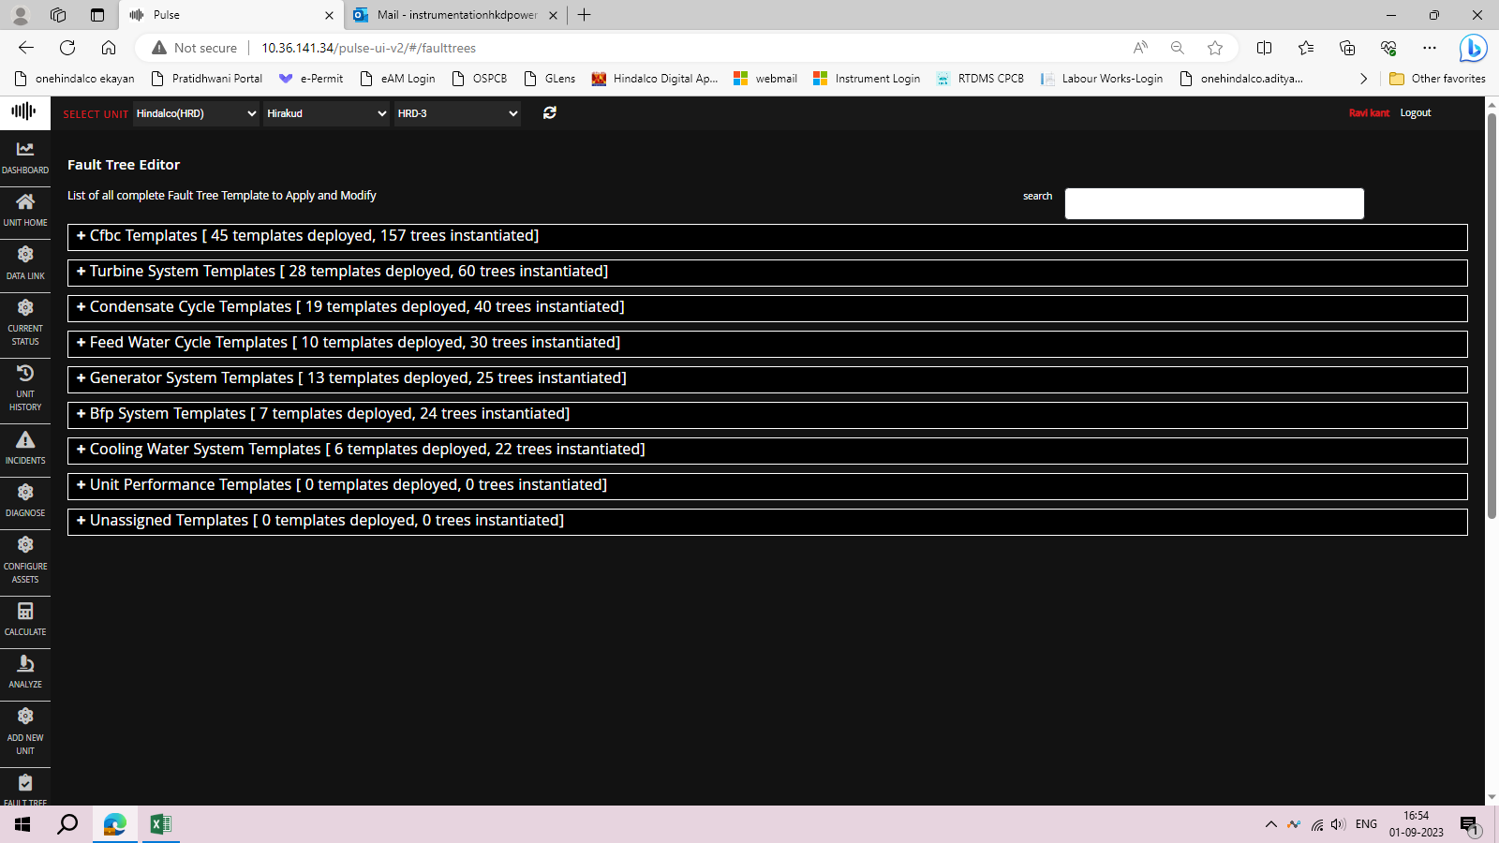

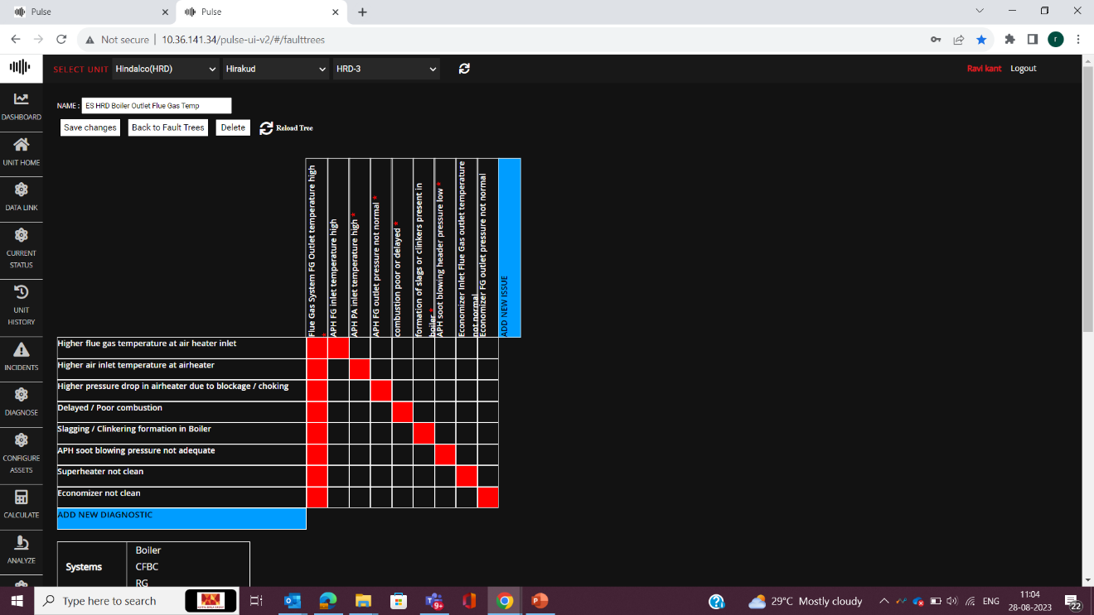

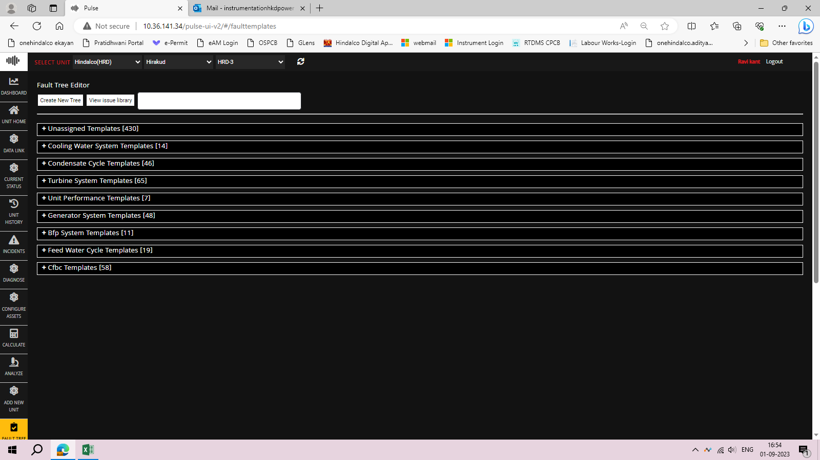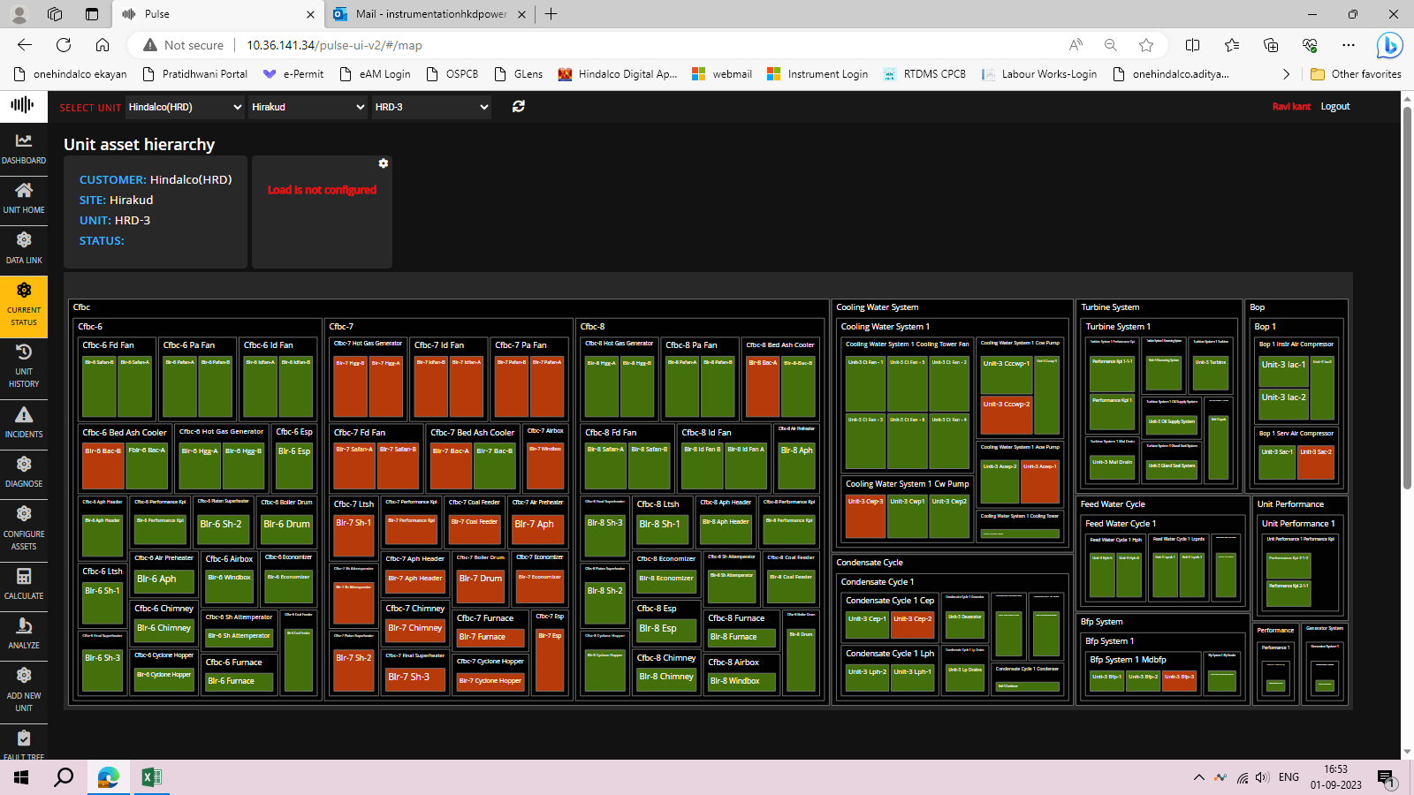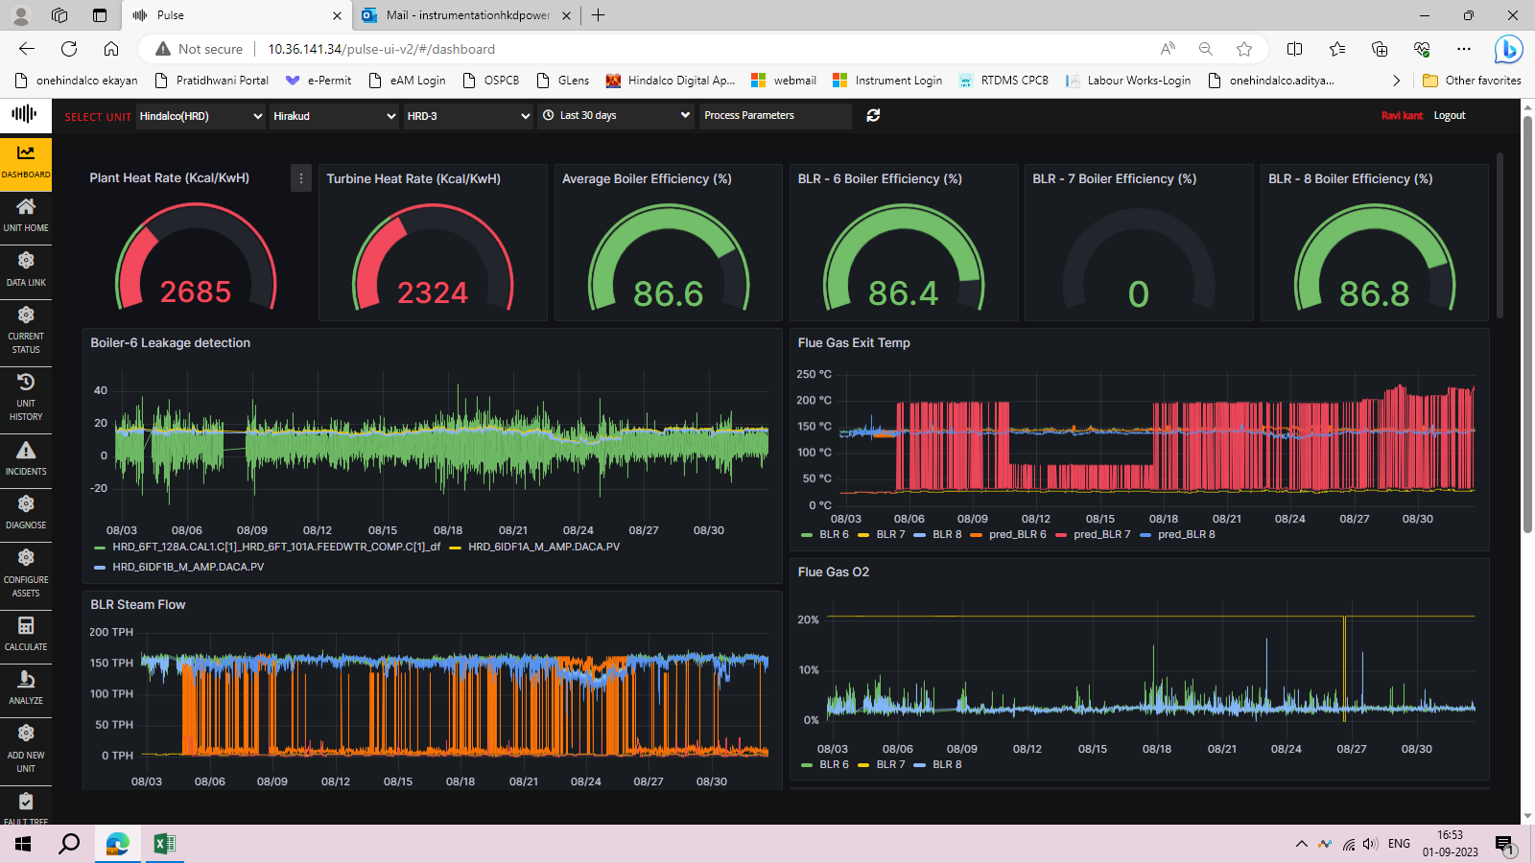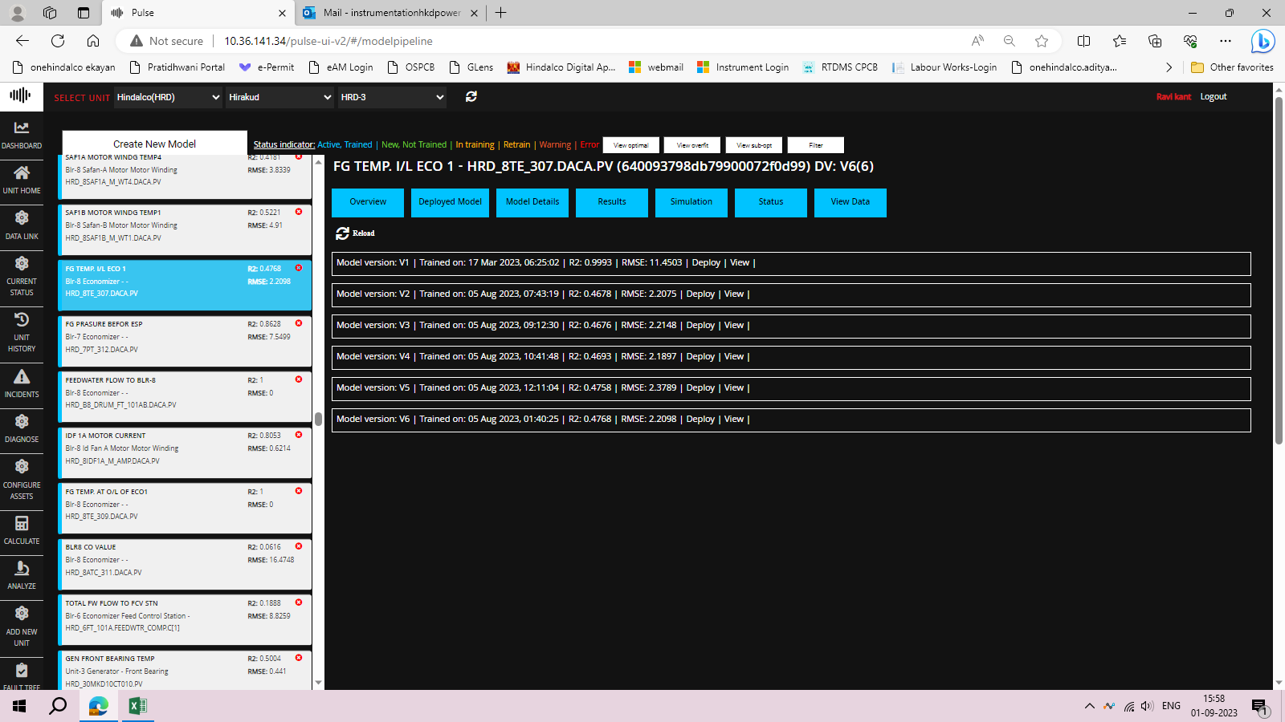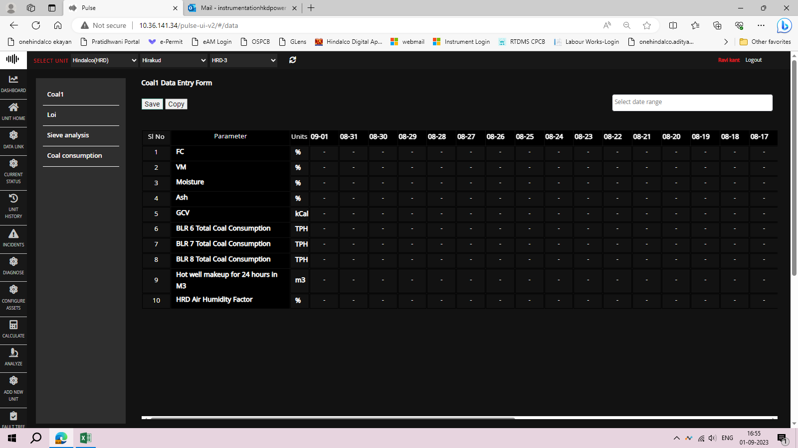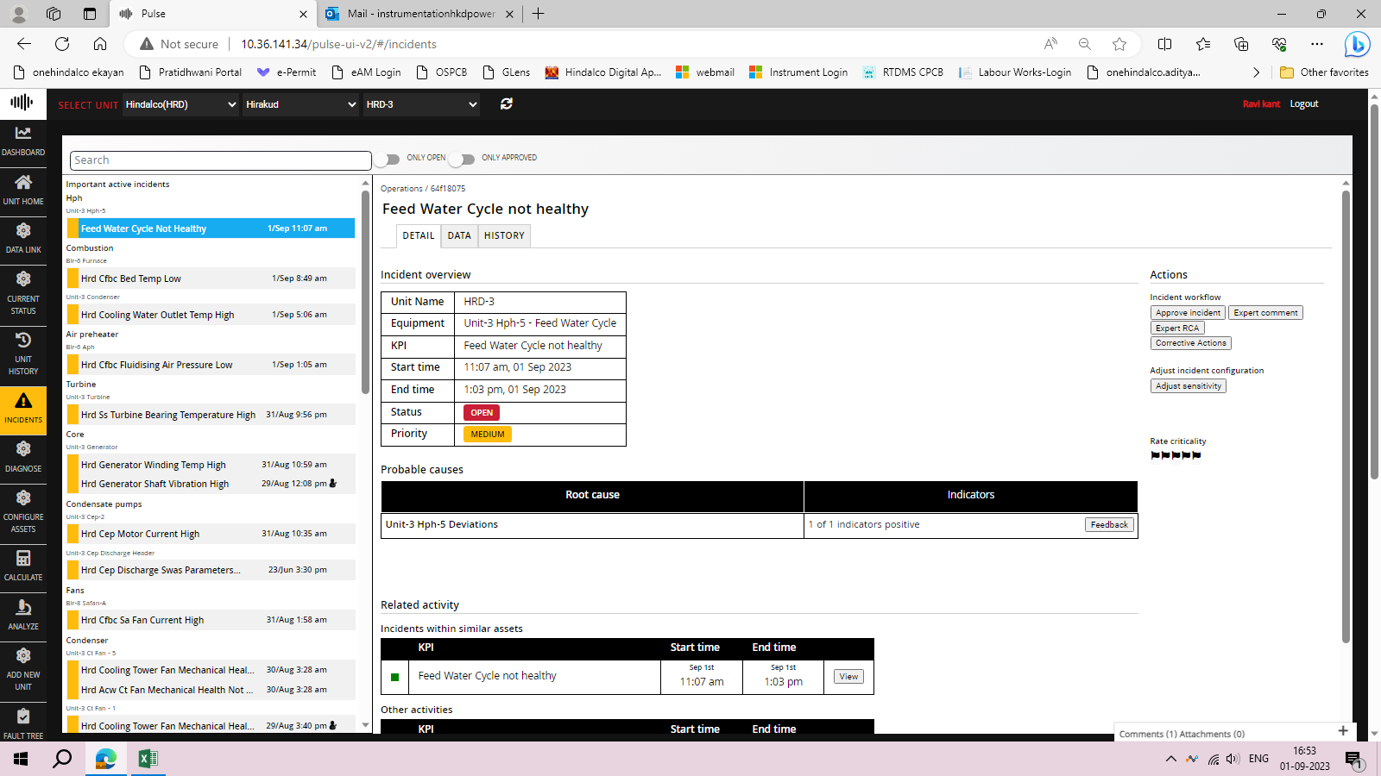

# Additional Insights:

Hirakud Power Plant is a coal based captive thermal power plant located near Hirakud in Sambalpur district in the Indian state of Odisha. The power plant began commercial production in April 2013, is operated by the Hindalco Industries. The plant supplies power to Hirakud smelter of Hindalco Industries. The coal for the plant is sourced from Talabira captive coal mines. It has an installed capacity of 467.5 MW.A factory with smoke stacks

Hirakud Power uses environmentally friendly circulating fluidized bed (CFB) combustion technology to produce electricity for one of the world’s oldest aluminum-smelting operations. This "captive power plant" has engineered a number of technical fixes to its original boiler designs to improve plant reliability and reduce outages and boiler repair costs. It also has made strategic investments in upgraded machinery to reduce auxiliary power consumption. In addition to an excellent environmental track record, as evidenced by being Asia’s first ISO 14001 (BS 7750) – certified power plant, Hirakud Power has solidified its position as an industry leader in CFB boiler operating experience and efficient power production.

**Areas Covered:**

* **PLC/DCS Flow Diagram**
* **Digitalization of VFDs**
* **SCADA System**
* **Power Station Wiring Layout**
* **KPIs**
* **FBD (Program Language)**
* **Boiler & TG Operations of U#3(of 5)**

**Control Room Servers:**

Turbine Control:

Boiler 8:

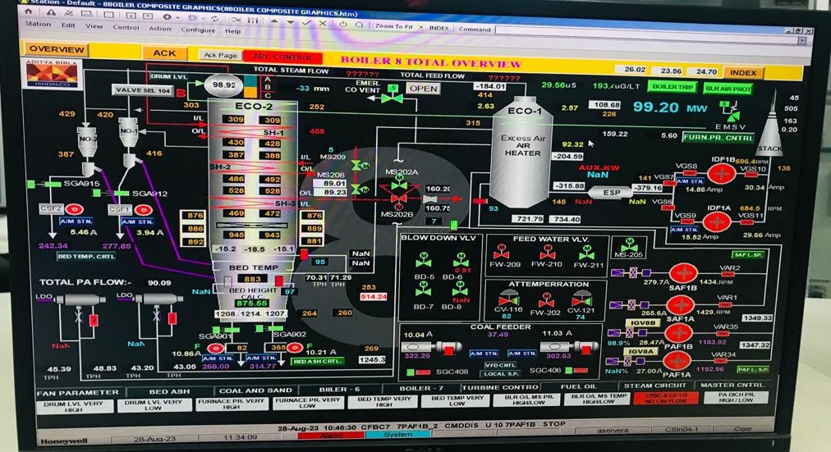

**Server Connection:**

Hindalco Hirakud’s Power Plant Processes:

Currently in use:

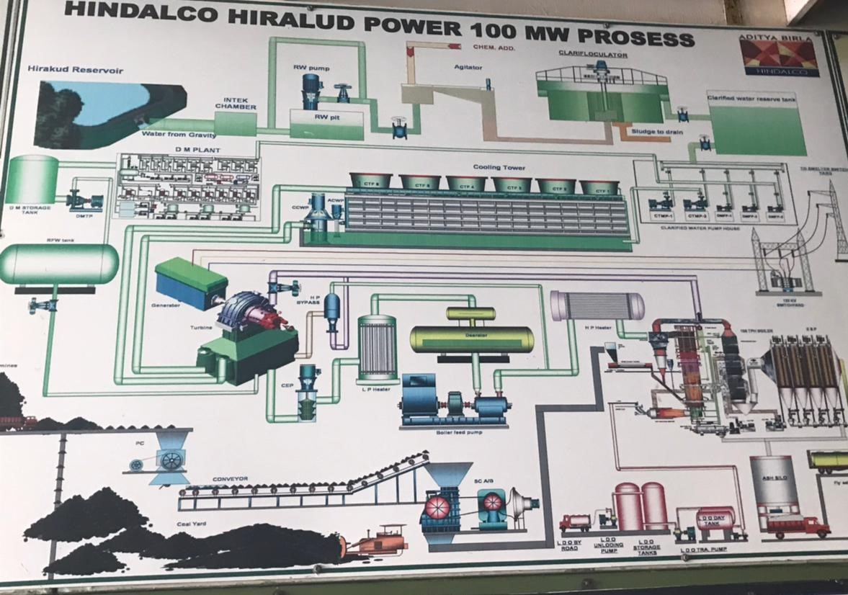

**Boiler Process(155 Tonne Per Hour):**

**OLDEST ESTABLISHMENT (Now Unused):**

# Conclusion:

I was able to identify anomalies and bridge the gap between domain expertise and machine learning models for better implementation and accuracy for future needs and demands with the assistance of industry experts who taught me about the operations of power plants, the current stage of digitalization in the plant, and the vendor's space of production of the digital twin model.

# Thank You